DATASHEET
BU-4062-C-*
(Shrouded Right Angle Banana to Test Probe, PVC Coiled Cord)

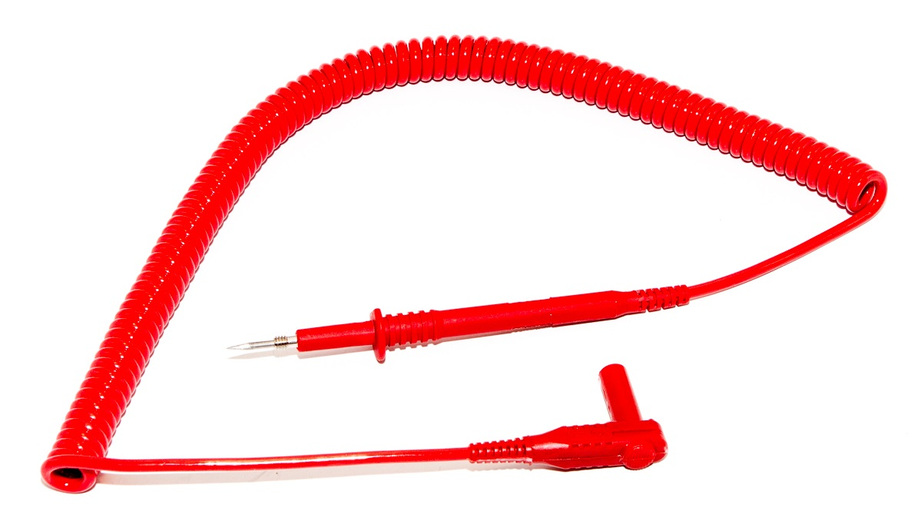

• Standard 4mm Shrouded Banana Plug to Test Probe with 8-32 thread.
• Banana plug is Nickel plated beryillium copper and brass
• Wire is 18 Coiled Cord with PVC Jacket.
Length is approximatly 2 feet (61 cm) and stretches to 9 feet (2.7 m)
• Ratings: 1000 V, 20 Amps.
Hands free testing to 3000V.
• Colors: Designated by “*” in the part number: Std. Colors are:
-0 black, and -2 red
• RoHS Compliant

