DATASHEET
BU-5050-B-XX-0
(Test Lead: Male BNC to Male BNC)
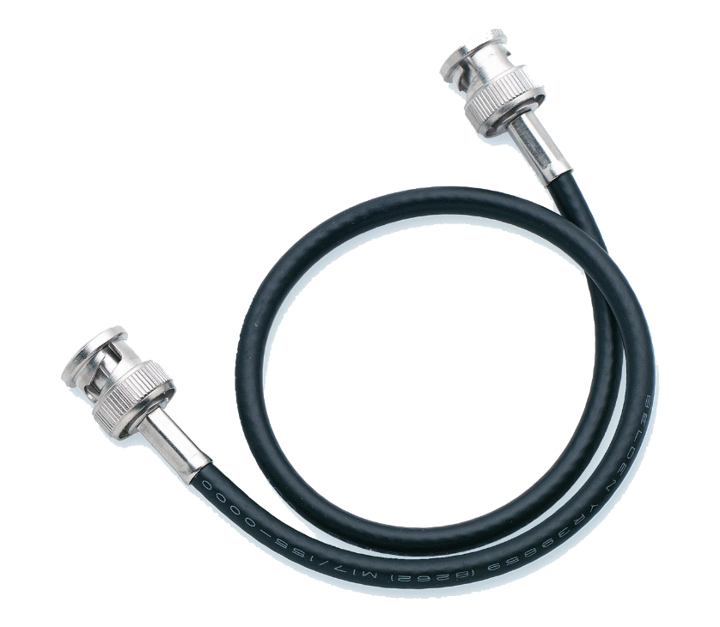
- Mueller’s BU-5050-B is a cable assembly with male BNC connectors on each end of an RG-58/U coaxial cable.
- Material: BNC body Silver-plated
BNC contact Gold-plated center conductor
- Rating: Impedance 50 Ohms
Voltage Hands-free testing to 500 VRMS
- Length: The “XX” in the part number indicates length in inches.
Standard lengths: 12”, 24”, 36”, 48”, 60”, 120”
(other lengths available upon request)
- RoHS 3 compliant, exemption 6c

