DATASHEET
BU-P5223-@
(Triaxial Cable Assembly, Male Both Ends)
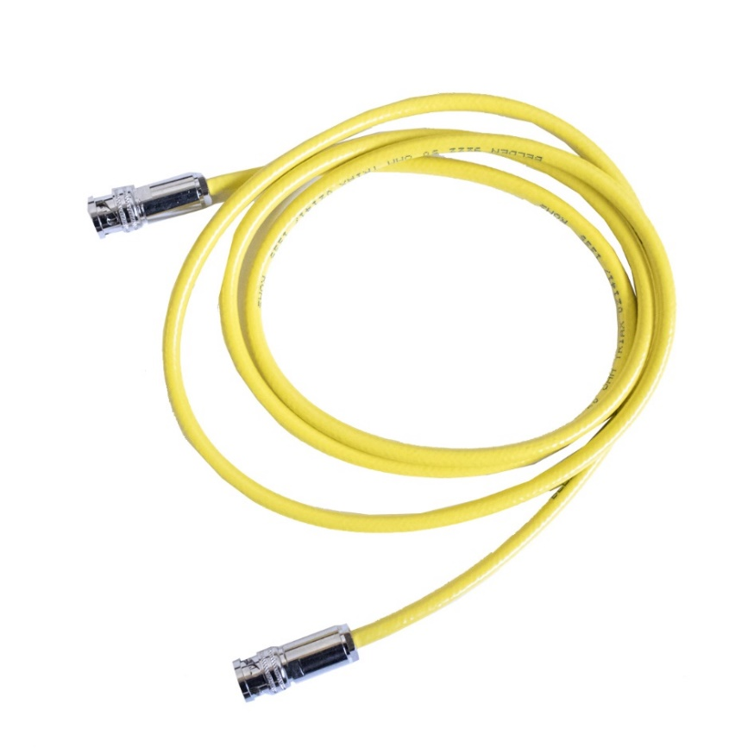
- BU-P5223 is a triaxial cable assembly with a male BNC connector at each end.
- Made with a Belden 9222 double shielded triaxial cable for use in high interference areas.
- Material: Triaxial cable male BNC, 3 lug bayonet style
Finish Tarnish-resistant brass
Center contacts Gold-plated
Cable insulation Polyethylene
- Ratings: Operating Voltage 500 VRMS/DC
Impedance, cable 50 Ohms
- The “@” in the model number represents the overall length in inches. Standard lengths are: 36”, 60”

